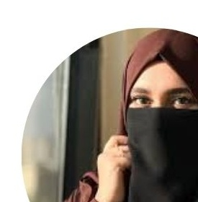 | TEHREEM  Computer Science Student
CONTACT  03166047180  tehreemcreatives@gmail.com  Wali Colony Habibabad, Pakistan  EDUCATION  BS Computer Science  University of Central Punjab  2023–2027(In progress)  ICS (Physics)  Punjab College Okara  2020–2022  Matric (Science)  First Nation School Pattoki  2018–2020  SKILLS  • Web Development (HTML, CSS, JavaScript, Bootstrap)  • Graphic Design (Canva & Adobe Photoshop)  • Video Editing  • Technical Writing & Documentation  • Attention to Detail & Creative Problem-Solving  • Digital & Computer Skills  LANGUAGES  English  Urdu |  | ABOUT ME  I am a Computer Science student with a strong interest in technology , digital  systems, and creative problem-solving. I have practical experience in web development, graphic design, documentation, and creating user-friendly digital content. I am a quick learner, detail-oriented, organized, and eager to improve  my professional and technical skills through new challenges and practical  experience.  PROJECTS & PRACTICAL EXPERIENCE  • Developed responsive websites and web pages using HTML, CSS, JavaScript,  and Bootstrap through university coursework and personal practice.  • Created user-friendly digital content and designs while following project requirements and maintaining attention to detail.  • Prepared technical and academic documents and presentations,  strengthening communication, organization, and documentation skills.  • Designed social media posts, banners, posters, thumbnails, presentations,  and promotional materials for academic and personal projects.  ADDITIONAL QUALIFICATION  Diploma in Graphic Designing (practical experience in Canva and Adobe  Photoshop).  KEY STRENGTHS  • Quick learner with willingness to learn new systems and procedures  • Strong attention to detail and accuracy in digital work  • Professional communication and documentation skills  • Comfortable working with computers and digital tools

